Pablo Casals Middle School 181
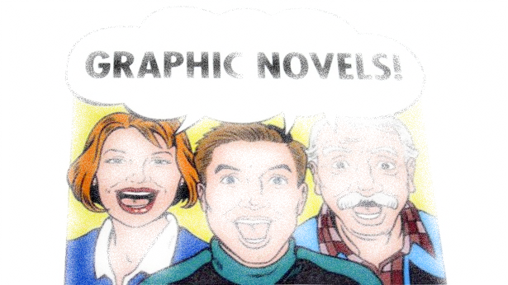
Name: ____________________ Class: ________ Date: _______
Subject: Literacy Focus: Narrative Writing
Culminating Activity - Using Middle School: The Worst Years of My Life as a model, create a graphic novel of an original narrative, a survival story.
In your graphic novel, be sure to
- Write a narrative in which you describe a change or challenge you or someone that you know is facing or has faced and how this challenge has shaped his/her life.
- Describe the events that led up to this challenge, the obstacle itself and how it was overcome. (30 points)
- Explain how this challenge has changed the outlook and define the life of the person (30 points)
- Use effective narrative techniques, relevant descriptive details, and well-structured sequence of events. (20 points)
- Illustrate your narrative using pen and pencil line drawings in cartoon strip format. (20 points)
Standards Met:
- CCLS W.6.3: Write narratives to develop real or imagined experiences or events using effective technique, relevant descriptive details, and well-structured event sequences.
- CCLS W.6.4: Produce clear and coherent writing in which the development, organization, and style are appropriate to task, purpose, and audience.
- CCLS W.6.5: With some guidance and support from peers and adults, develop and strengthen writing as needed by planning, revising, editing, rewriting, or trying a new approach.
- CCLS L.6.2: Demonstrate command of the conventions of Standard English capitalization, punctuation, and spelling when writing.
Comments:
______________________________________________________________________________________________________________________________________________________________________________________________________________________________________________________________________________________________________________________________________________________________________________________________________________________________________________________________________________________________________________________________________________________________________________________________________________________________________________________________________________________________________________________________________________________________________________________________________________________________________________________________________________________________________________________________________________________________________________________________________________________________________________________________________________________________________________________________________________________________________________________________________________________________________________________________________________________________________________________________________________________________________________________________________________________________________________________________________________________________________________________________________________________________________________________________________________________________________________________________________________________________________________________________________________________________________________________________________________________________________________________________________________________________________________________________________________________________________________________________________________________________________________________________________________________________________________________________________________________________________________________________________________________________________________________________________________________________________________________________________________________________________________________________________________________________________________________________________________________________________________________________________________________________________________________________________________________________________________________________________________________________________________________________________________________________________________________________________________________________________________________________________________________________________________________________________________________________________________________________________________________________________________________________________________________________________________________________________________________________________________________________________________________________________________________________________________________________________________________________________________________________________________________________________________________________________________________________________________________________________________________________________________________________________________________________________________________________________________________________________________________________________________________________________________________________________________k

